**BALIHAR VILLAGE**

***An important new NGO looking after the elderly and orphans, and***

***creating permaculture and eco-holidays in rural Odisha…***

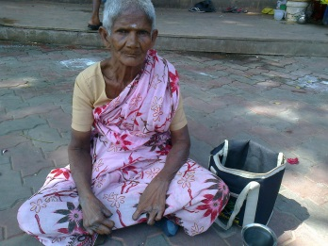 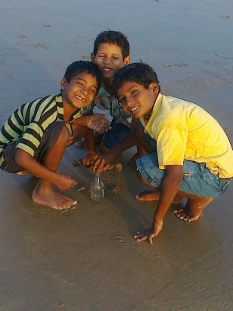  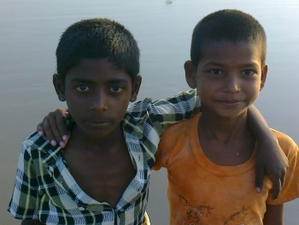

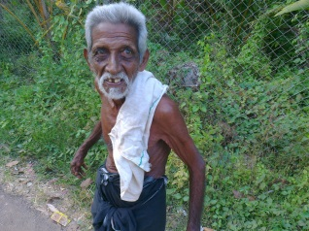 [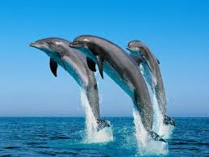](https://www.google.co.uk/imgres?imgurl=http://www.coastaltourism.in/wp-content/uploads/2013/11/Chilika-lake-Dolphin.jpg&imgrefurl=http://www.coastaltourism.in/chilika-lake/&h=300&w=400&tbnid=chsmglgpDNEBYM:&docid=BXLNyaMa_tKUcM&hl=en-GB&ei=NM1dVoCPPIqxaeiIovAL&tbm=isch&ved=0ahUKEwiA-dbjjLvJAhWKWBoKHWiECL4QMwgiKAEwAQ) 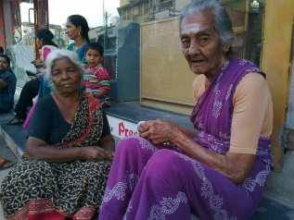

We plan to build a small village 28 kilometres from the Odishan town of Puri in Eastern India, including natural mud-and-straw huts for eco-tourists – and living spaces for thirty elderly homeless people and orphans.

Visitors will be able to see a purer India and study the biodiversity, flora and fauna of the region. They will experience our dedication to permaculture and organic farming in an idyllic spot by the Bhargavi River near the Bay of Bengal.

Nearby, Chilika Lake is well-known for its dolphins, and the Bay of Bengal boasts an annual migration of Olive Ridley Sea Turtles. Birds, including storks and flamingos, flock into the area from all over the world. In the forest are jackals, snakes, monitor lizards, deer, mongooses, wild cats and many other species.

Two small temples – *Mukteshwar*, dedicated to Siva, and the other to the goddess *Baliharachandi* – are also close by. In Puri there is the world-famous *Jagannath* Temple*.* Beyond the town, at *Konark*, is the 13th century temple built as a vast stone chariot for the sun god.

A vital part of the project is giving a permanent home to the poor. Fifteen elderly men and women and 15 orphaned children will be looked after. They will be saved from the horror and loneliness of their situation. *Will you please spread the word among friends so that we can raise donations to make this possible?*

Here is the plan…

*1. The project. 2. Staff and supporters. 3. The village. 4. Tourist attractions. 5. Financing.*  
  
*1. THE PROJECT.*

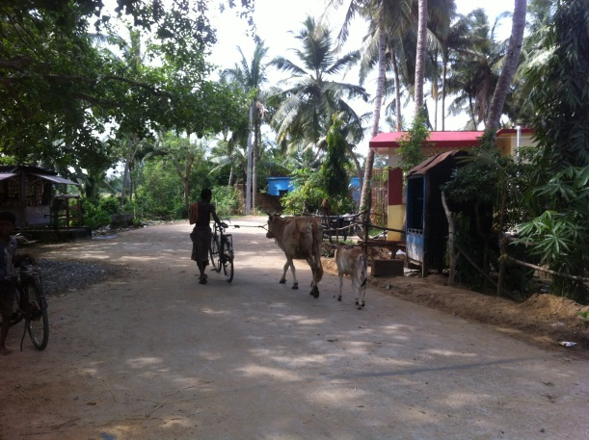 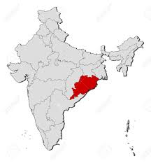 *Odisha* 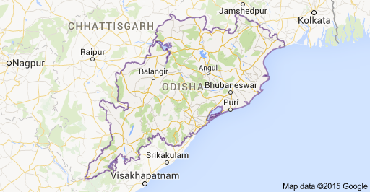

The purpose of this project is to create a self-sufficient village, consisting of a small school, a home for the elderly, up to eight mud-and-straw houses to accommodate tourists, staff premises and a camp site. There will also be a dormitory, kitchen, dining room, workshop and library. Income from eco-tourism should fund the cost of supporting the rural poor.

All fruit and vegetables consumed will be grown on the land: coconuts, bananas, pomegranates, pineapples, potatoes, aubergines, carrots, radishes, onions, garlic, beans, etc. We will also operate a tree-planting scheme.

A key challenge is to allow poor children to attend school and aim for higher education in order to support themselves. Apart from receiving a contemporary schooling, they will hear traditional stories from old people steeped in Odisha’s culture. The tourists will also hear translated versions of these tales. Children from the neighbouring village will also be able to attend.

We want poor rural people to continue having a say in the running of the land, at a time when so much of it is being taken over by large financial groups.

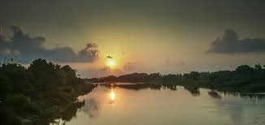

*Bhargavi River*

*2. STAFF AND SUPPORTERS.*

Simon Howard and Santosh Kumar Barik will lead the administration of the NGO. The project is Santosh’s brainchild. Simon, a screenwriter and teacher, is an old India hand.

A jewellery designer and shopkeeper, Santosh, 32, also has years of experience as a tour guide and NGO volunteer. For a decade and a half he has been Simon’s assistant in India, thereby learning the work of Boys Town Society and SPPD (Society for Poor People Development) in Tamil Nadu, and the Mathieson Music School in Kolkata. He has overseen several of Simon’s projects for sick children and the poor, and been a volunteer with the Life of Hope NGO in Kolkata, looking after street children and arranging medical help for people in need. He is a member of Sundarban Backpackers Eco-Village and a partner in Puri Backpackers. A native of Puri, he speaks Oriya, English, Hindi, Bengali and Telugu, and also has a smattering of Japanese, French and Italian…

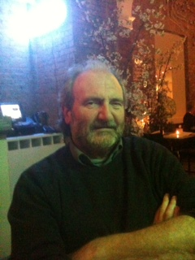 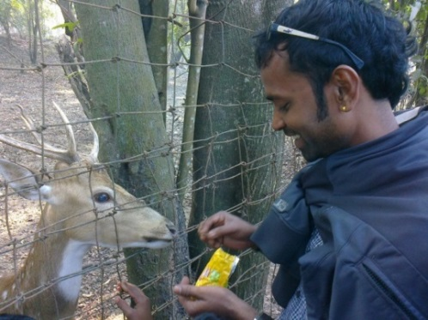

*Simon Howard Santosh Kumar Barik*

Santosh will organize a team of four guides who will take it in turns to conduct the project’s eco-tours: Bapi, Mantu, Pratap and Chandan, former street boys from Puri.

A cook will prepare meals for the tourists, the elderly, orphans and staff. All fruit and vegetables will be supplied from our own garden. Tourists can choose local or Western food.

We will also employ:

One kitchen assistant, one dining room assistant and two cleaners.

One driver to transport guests, goods, food, staff, etc.

Two full-time teachers, and one part-time retired teacher, assisted by volunteers.  
 One gardener to oversee our own produce, trees and flowers.

One maintenance worker: water supply, electricity, handiwork, etc.

One night watchman.

A volunteer – Myako, from Japan – will run massage workshops for villagers,

children, tourists and the elderly…

[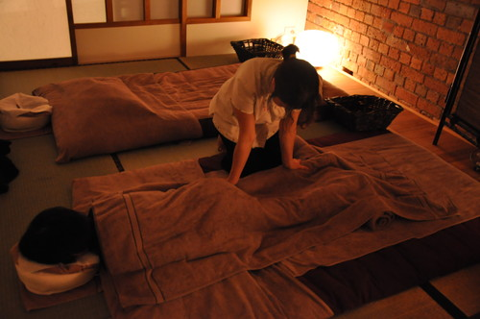](https://www.google.co.uk/url?sa=i&source=imgres&cd=&cad=rja&uact=8&ved=0ahUKEwjL3O2fnLvJAhXHSRoKHaKTCJ4QjRwICTAA&url=http://www.japaninmelbourne.com.au/artice677/&psig=AFQjCNFAq4vjCDEo15IgATCXCXVcd8ALhw&ust=1449078509836960) *Massage*

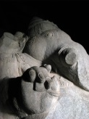 *Visit us at:*

[www.baliharvillage.com](http://www.baliharvillage.com)

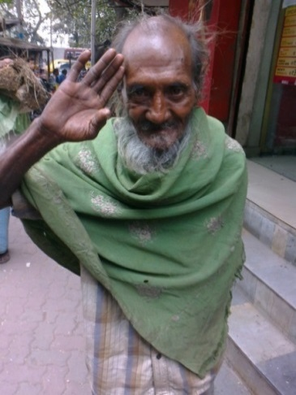 *‘Namaskar!’* 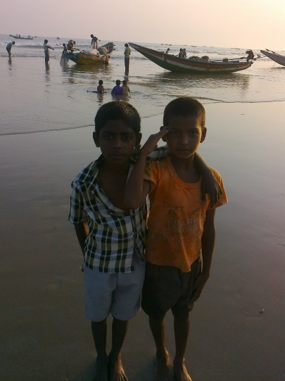

Here are some of our supporters:

 Julia Hamilton is a novelist who is putting the finishing touches to her seventh novel, *The Cairo Journals*.  She has also written for many publications, including *The Independent*, *The Oldie* and the *Daily Mail*.  She lives in Oxford with her liver-spotted Dalmatian, Millie.

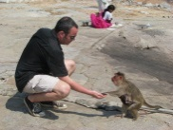 Simon Beckwith trained as a lawyer at the London School of African and Oriental Studies before qualifying as a barrister and solicitor. He now works for a City law firm. He and Simon Howard have travelled together frequently in India.

 Christina Munday read History at Oxford and worked as a chartered accountant in the City before switching to advertising, PR and design. She was Mayoress of Kensington and Chelsea and fund-raised for *The Queen Elizabeth Diamond Jubilee Trust*, *SSAFA*, the *Royal British Legion* and *Marie Curie*.

 Aruna Mathur was born in Oxford, lived in India as a child and continues to visit India and her Indian family. She studied as a graphic artist, which led to a career in publishing as a designer and art director. Since then she has worked as a coordinator and mentor for four years on a *Refugees into Teaching* project funded and monitored by the Home Office. She is currently training to become a counsellor.

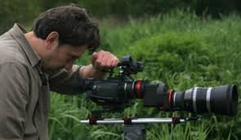 Laurentiu Huianu, film-maker and producer at Norfolk & Norwich University Hospital; director of *SWIFF* film festival, London. Responsible for our publicity, he has worked for *Amnesty International* in London and the *Red Cross* in Romania and the *FAO*.

 Elizabeth Randall is a chartered architect, working in property development and construction, particularly managing the design, planning and delivery of large mixed use regeneration projects – currently Elephant Park in London.

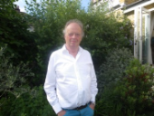 Charles Marriott, BSc (Lond.), BA (Lond.) FRICS. Retired surveyor, property developer and experience in commercial valuation. He will lead our fund-raising.

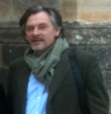 Born in Borneo, Alasdair Clayre studied Theology and then Social Anthropology at Cambridge. Over the years he has been involved in tourism and ecotourism, from running *Downton Abbey* tours in England to setting up community-based conservation projects in Sarawak, where he still spends much of his time.

 Beatrice Colomb is an Anglo-Italian undergraduate, studying Classics at St Anne’s College, Oxford. Bea is our student representative.

 Simon Howard has been a film-maker, theatre director, journalist, screenwriter and lecturer. He has spent a vast amount of time in India and knows a lot of NGOs there.

***

*3. THE VILLAGE.*

Balihar will be built around the school. It will occupy one acre of land. Later, we plan to build a small temple dedicated to the villagers’ chosen deity…

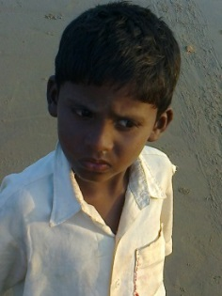 *Local boy* [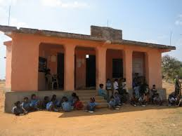](https://www.google.co.uk/imgres?imgurl=https://upload.wikimedia.org/wikipedia/commons/c/c6/Orissa_school.JPG&imgrefurl=https://en.wikipedia.org/wiki/Kantabanjhi&h=1944&w=2592&tbnid=ISaJn0ZjgbdubM:&docid=nUzOsUl2D4wUBM&hl=en-GB&ei=C9ldVvmDKoT2aIGrg9AD&tbm=isch&ved=0ahUKEwi5teqImLvJAhUEOxoKHYHVADoQMwhIKB0wHQ)

*An Indian village school*

Five houses will be built out of brick, mud and cement:

A dormitory for the orphan children.

A dwelling for the homeless elderly people.

A large building for the staff, including a kitchen, dining room and library.

The school house.

A workshop for the children, elderly and volunteers to learn and teach skills and handicrafts.

Tourists will be accommodated in comfortable eco-friendly mud-and-straw huts with en suite bathrooms…

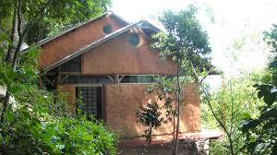

*Proposed hut and bedroom*

[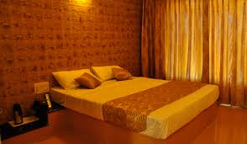](https://www.google.co.uk/imgres?imgurl=http://www.countryvacationskodaikanal.com/tabs_jquery/photos/big-kodai4.jpg&imgrefurl=http://www.countryvacationskodaikanal.com/country-vacations-kodaikanal.php&h=350&w=600&tbnid=XR3e2FakPCboRM:&docid=85I_3Fi2Ng2j9M&hl=en-GB&ei=CfZeVqagGsOpa8OGqcgN&tbm=isch&ved=0ahUKEwjmyOXtp73JAhXD1BoKHUNDCtk4yAEQMwg7KDgwOA)

The buildings will be powered by electricity and solar panels.

Part of the land will also be used as a camp site for tourists.

We’ll be happy to accommodate volunteers – some from other NGOs – in exchange for a donation, so that we can share ideas about various schemes to help the poor, etc. They will stay between 15 and 30 days.

The children will get up one hour before school, bathe and have breakfast. The rest of the morning will be spent in the classroom. After lunch they will play or take a nap before resuming lessons. Later on they’ll engage in workshops: reading, chess, music, painting, cooking, dancing, gardening, films, etc. They will also listen to traditional tales, including Hindu epics, told by old storytellers. What they won’t hear is outdated caste prejudice.

Older children will mentor the younger ones.

For entirely practical reasons, we’ll need a minibus and a motorboat.

One day we’ll launch an eco-friendly film festival using solar power…

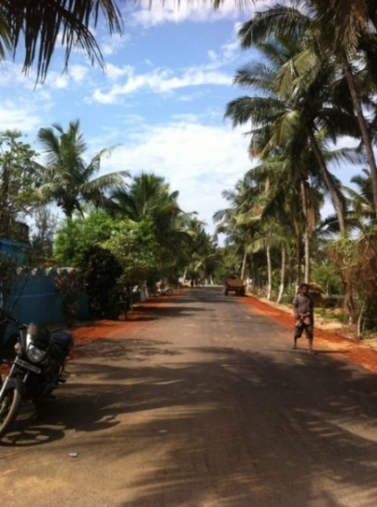 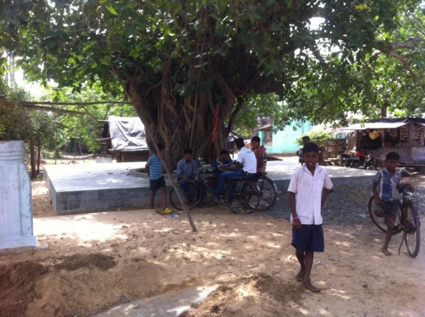

*The road… Schoolchildren from the village nearby*

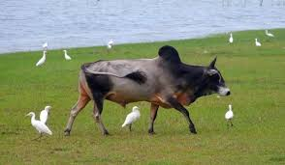 *Round the lake*

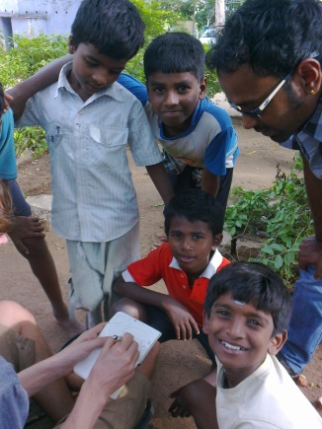 *NGO kids* 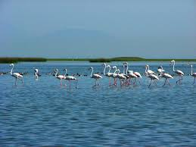

*Flamingos on Chilika Lake*

*4. TOURIST ATTRACTIONS.*

The village will be 28 km from Puri, famous all over the world for its *Jagannath* Temple. Much nearer are *Mukteshwar* and *Baliharachandi* Temples.

A huge number of tourists visit Chilika Lake, just over twenty km away. Attractions include dolphin-watching, fishing, exploration of local wildlife and flora. A beautiful little temple, *Kalijai*, is situated in the middle of the lake…

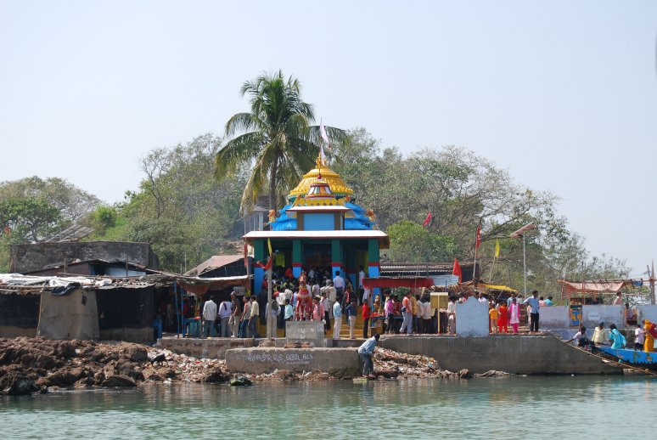 *Kalijai Temple*

*Sunset on the lake 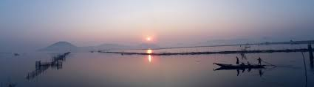*

The Bay of Bengal hosts the Olive Ridley Sea Turtles, which migrate annually to the beaches of Odisha, as do birds from all over the world…

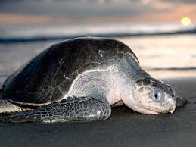 *Olive Ridley Sea Turtle* [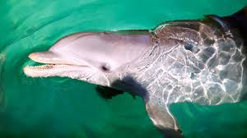](https://www.google.co.uk/imgres?imgurl=http://planetden.com/wp-content/uploads/2014/04/irrawaddy.jpg&imgrefurl=http://planetden.com/history/paradise-bird-watchers-chilika&h=369&w=656&tbnid=J2MjcMFhl-tTmM:&docid=Re3KO0LD1xIbBM&hl=en-GB&ei=BiVfVtrIKsqNarDprVg&tbm=isch&ved=0ahUKEwja4-XV1L3JAhXKhhoKHbB0CwsQMwhEKB0wHQ) *Irrawaddy dolphin*

*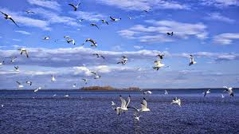 Birdlife on Chilika Lake*

An hour’s drive from the village brings you to the extraordinary *Konark* Temple, which is

quite unlike any other temple in Odisha – or India. Built in the 13th century as a vast chariot

for the sun god, it is a UNESCO World Heritage Site…

[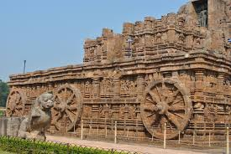](https://www.google.co.uk/imgres?imgurl=http://www.travelpal.eu/uploads/tinymce/1.JPG&imgrefurl=http://www.travelpal.eu/blog/detail/the-mysterious-konark-sun-temple-%E2%80%93-finding-some-answers-20&h=1071&w=1600&tbnid=xML7oKSfJei_FM:&docid=RSpdkxZJqPqnCM&hl=en-GB&ei=f9FdVsSnNIXzaKrLlsAF&tbm=isch&ved=0ahUKEwiE49TvkLvJAhWFORoKHaqlBVgQMwgqKA4wDg) *Konark Temple*

[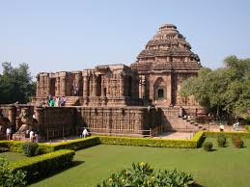](https://www.google.co.uk/imgres?imgurl=http://www.fabulousodisha.com/wp-content/uploads/2015/01/konark.jpg&imgrefurl=http://www.fabulousodisha.com/odisha-heritage/konark-sun-temple/&h=1200&w=1600&tbnid=jhg6vwWQS9_76M:&docid=hxqb59Jv-RA2gM&hl=en-GB&ei=E9pdVuumA8j7aZ_tjdAP&tbm=isch&ved=0ahUKEwir_LSGmbvJAhXIfRoKHZ92A_oQMwhBKBowGg)

Another great place to visit is Rathurajpur Artists’ Village, where local craftspeople create works out of silk and palm leaves, among many other materials…

[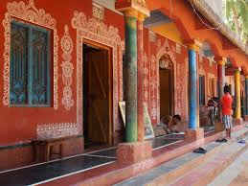](https://www.google.co.uk/imgres?imgurl=http://www.kalanirvanacreatives.com/wp-content/uploads/2013/09/pattachitra_image_01.jpg&imgrefurl=http://www.kalanirvanacreatives.com/kiar-international-photo-tour/&h=600&w=800&tbnid=pvY9IiSU2u9krM:&docid=28x1yTR5tvQtiM&hl=en-GB&ei=ntRdVpL1BsmMauiNmtAG&tbm=isch&ved=0ahUKEwiSvKbsk7vJAhVJhhoKHeiGBmoQMwgmKAUwBQ) *Artists’ Village*

[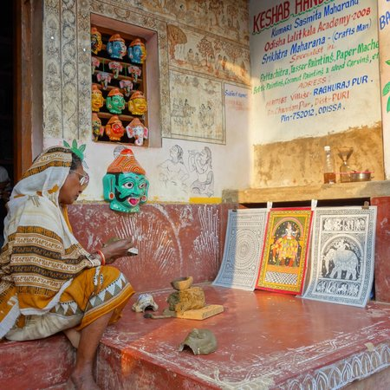](http://www.google.co.uk/url?sa=i&rct=j&q=&esrc=s&source=images&cd=&cad=rja&uact=8&ved=0ahUKEwig3Iztk7vJAhWHWRoKHQBPDXYQjRwIBw&url=http://www.tripadvisor.in/Attraction_Review-g503703-d3806619-Reviews-Raghurajpur_Artist_Village-Puri_Odisha.html&psig=AFQjCNE3GXwilSypZUmlo2eXFQIw57T7_A&ust=1449076254684992)

There is wonderful swimming to be had in Bhargavi River and the sea. An ‘Empty Beach’ stretches for miles…

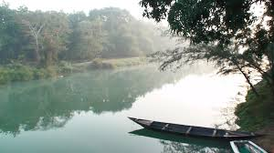 *Bhargavi River*

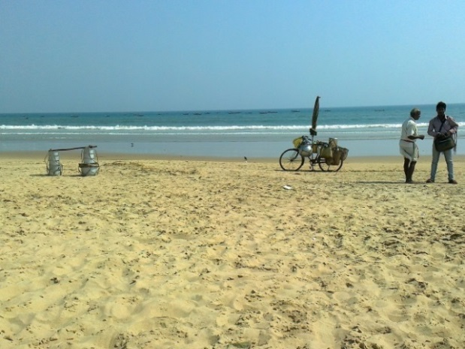

*Puri beach*

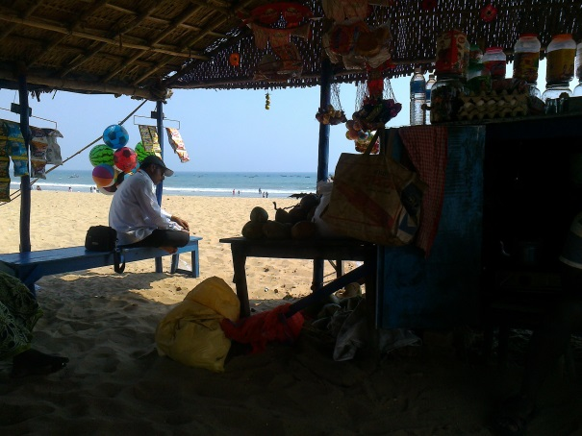 *Beach shop*

*Santosh’s motor-bike on the ‘Empty Beach’* 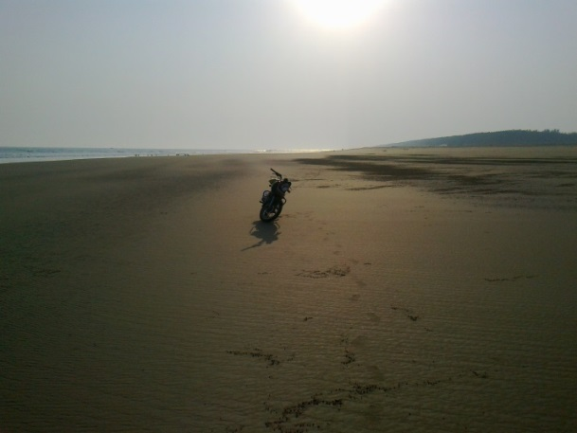

For braver tourists, trips can be arranged to Odisha’s famous tribal areas. They’ll be pricey, though, because the state Government has to guarantee your security in these turbulent times…

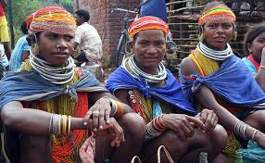 *Tribal people…*

[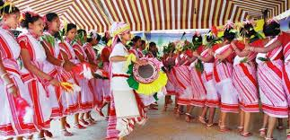](https://www.google.co.uk/imgres?imgurl=http://www.tribestourorissa.com/images/gallery/orissa-tribal-dance.jpg&imgrefurl=http://www.tribestourorissa.com/tribal-weekly-market-in-orissa.html&h=320&w=660&tbnid=R3t8h-NnHjDHqM:&docid=0TyXIZVmcXujAM&hl=en-GB&ei=buteVonSBMe2a8vMhoAK&tbm=isch&ved=0ahUKEwiJwYHfnb3JAhVH2xoKHUumAaAQMwhKKCMwIw)

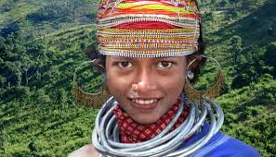

[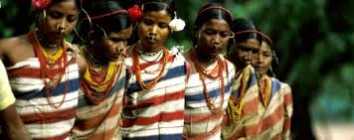](https://www.google.co.uk/imgres?imgurl=http://travellink-india.com/home/wp-content/uploads/strikingr/images/2395_gadaba-tribe-dhemsa-dance-628x250.jpg&imgrefurl=http://travellink-india.com/explore-and-experience-odisha/odishas-tribal-festival/&h=250&w=628&tbnid=CEKLP2eeBijjyM:&docid=3SHnwXnEcEYyYM&hl=en-GB&ei=buteVonSBMe2a8vMhoAK&tbm=isch&ved=0ahUKEwiJwYHfnb3JAhVH2xoKHUumAaAQMwgtKBAwEA)

Puri has a well-known fishermen’s village, supporting a vast population of poor men, women and children in cramped, sparse conditions. Life on their beach, though, is a thrilling spectacle…

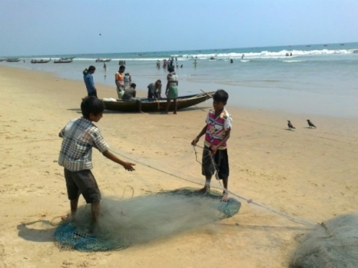 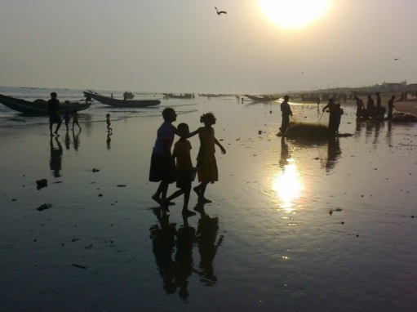

*Fishermen’s village....*

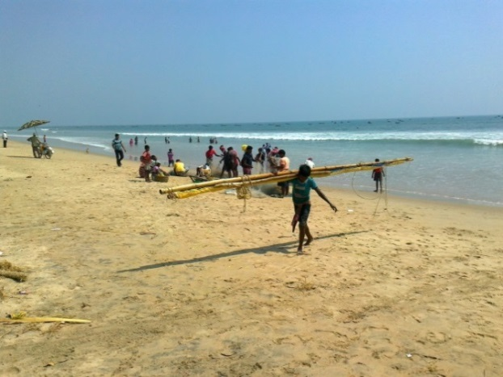 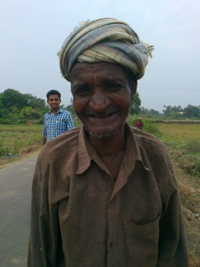

*....young and old....*

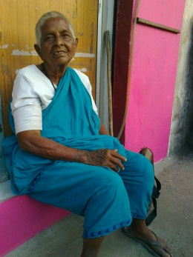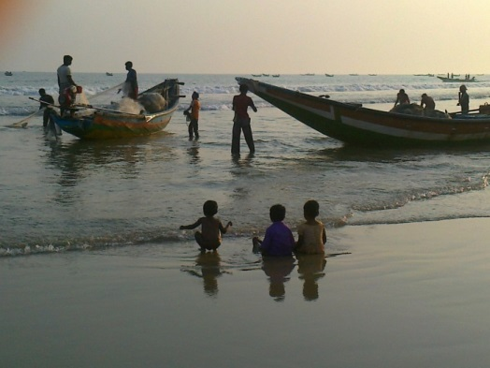 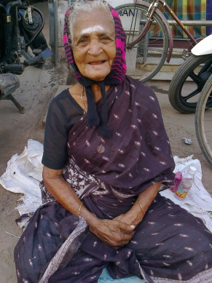

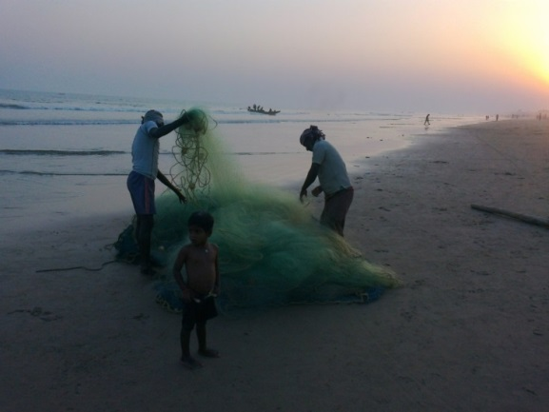 *....fishermen’s friend*

*5. FINANCING.*

The village will be owned by the NGO, which will be registered in India where foreigners are not allowed to own land, except in certain circumstances. A committee will be set up.

*Estimated costs:*  
  
Land purchase (one acre): Rs 12 lakhs (approx. £12,000).

Registration fee (30%), payable to the state government: Rs 3 lakhs (approx. £3,000).  
Site preparation/development: Rs 2 lakhs (approx. £2,000).   
Building construction/labour: Rs 22 lakhs (approx. £22,000). *This figure could change.*  
Minibus (Tata Winger: Rs 3 lakhs, 80,000 (approx. £3,800).

Motor Insurance, per annum: Rs 15,000 (approx £150).

Motorboat: Rs Rs 85,000 (approx. £850).  
Other insurances: *Yet to be confirmed.*

Broadband costs. *Yet to be confirmed.*

*TOTAL COSTS ESTIMATED SO FAR:* £43,800

*Salaries (per month):*

Teachers (2, full-time): Rs 10,000 *each* (£100). £200

Teacher (part-time): Rs 3,000 (£30). 30

Cook: Rs 6,000 (£60). 60

Organizer (Santosh): Rs 12,000 (£120). 120  
Kitchen assistant: Rs 4,000 (£40). 40

Dining room assistant: Rs 4,000 (£40). 40

Driver: Rs 7,000 (£70). 70

Gardener: Rs 4,500 (£45). 45

Cleaners (2): Rs 4,000 *each* (£40). 80

Maintenance: Rs 6,000 (£60). 60

Night watchman: Rs 5,500 (£55). 55

Guides (2, when employed): Rs 5,000 *each* (£50). 100

*MONTHLY TOTAL:* £900

*****

[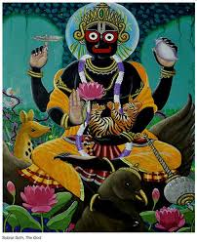](https://www.google.co.uk/imgres?imgurl=http://incredibleorissa.com/wp-content/uploads/painting-of-Jagannath.jpg&imgrefurl=http://incredibleorissa.com/lord-jagannath-paintings-by-famous-painters-of-odisha/&h=762&w=620&tbnid=kJ1YKjI1s_JIcM:&docid=25wmT5zZ74WPjM&hl=en-GB&ei=AylfVsyWBIfwat_BhbAH&tbm=isch&ved=0ahUKEwiMpKy82L3JAhUHuBoKHd9gAXY4ZBAzCDUoMjAy) *Jagannath* 